# **Main Solution:**

You are expected to copy the nc command which is as follows, going into it we can see that it executes an app that prints each character ONE BY ONE

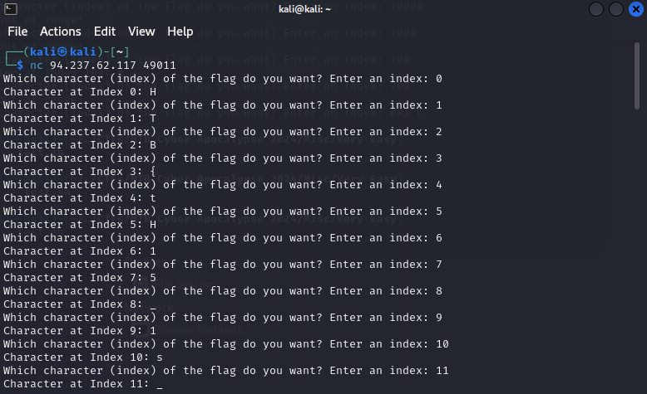

**WELL DEFINITELY NOT GOING TO DO IT MANUALLY**

Firstly, to establish a baseline, i.e. how big of a number I would likely need,

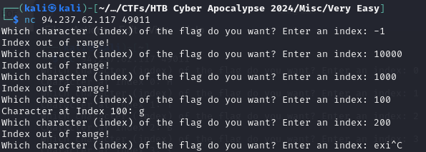

Good to see that you did handled for exceptions, but we can see that the safe side is about 100+- there are still some parts of the string so we can establish that approx is 0 to 200 minimally.

So I did a bash script with my limited knowledge of bash scripting (for now), the following does the connects to the specified IP address and PORT using nc and then sends inputs of 0 to 200

*NOTE: in case you are new to linux in general, in order to run this you would minimally need to **chmod +x test.sh** before doing a **./test.sh**

## **test.sh**

#!/bin/bash

# IP address and port to connect to

IP="94.237.62.117"

PORT="49011"

# Connect using nc

nc "$IP" "$PORT" << EOF

$(seq 0 200)

EOF

After running the above test.sh copy all the lines excluding the last line before you terminate (ctrl+c) the sh file to a txt file.

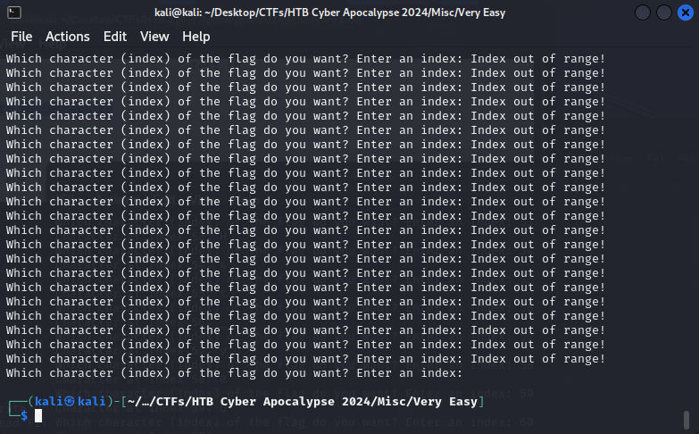

Python script that helps to parse the data of the txt file to give you the final flag

## **test.py**

#Usage: python3 test.py <text file> e.g. python3 test.py test.txt

import sys

f = open(sys.argv[1], "r")

temp = ""

i=0

for x in f:

#this is to check in case you decided to copy the index out of range ones also

if "Index out of range!" in x:

continue

else:

temp += x.replace('Which character (index) of the flag do you want? Enter an index: Character at Index ' + str(i) + ': ', '').rstrip()

i+=1

print(temp)

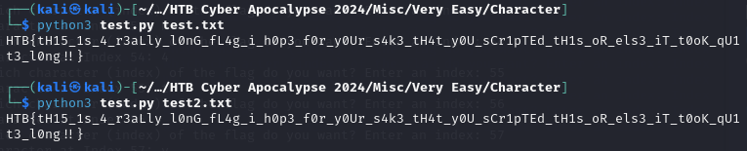

The above shows 2 different txt files, one containing only the lines that contains characters of the flag and the other txt file contains all lines include the index out of range lines